Source:

(<http://simscrane.com/how-determine-center-gravity-any-load/>)

Center of gravity is the “center of weight” in any object, regardless of shape or size.

For primitive shapes, such as spheres, circles, squares and cubes the center of gravity will be the very center of the object because the mass is distributed evenly around it.

But for more complex objects it would be necessary to determine the center of gravity (CoG) for before being able to determine how it would react to Torque if it isn’t pivoting around anything. A good example of torque with “no pivot point” is balance. Gravity works on the objects CoG as though it were the pivoting point and the rotates the object accordingly.

The easiest way to get the center of gravity is to create a reference point (X, Y or X, Y and Z coordinate graph) and put the object onto the reference.

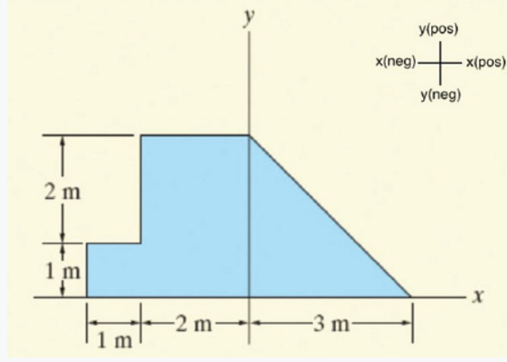

Like so.

So long as the object is made of the same materials you don’t need to worry about what materials or mass make up the object as all of it would wind up having the same effect on the object’s CoG.

Once you have your reference and object, ‘split’ the object into primitive shapes then find and collect each of their CoG,

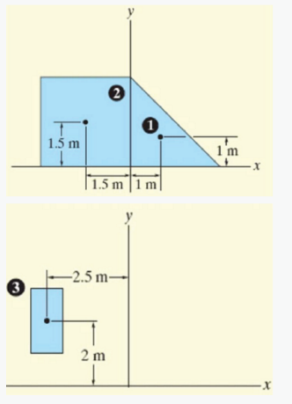

if the object has holes or sections of ‘nothingness’ you can treat them as being part of the primitive shape on the condition that you create a shape for them and find its CoG for those holes and note them as being “Void space” (for subtracting their effect later).

This would be an example of splitting the object into smaller shapes, It also has object 3 as the “void space”.

The things to collect for each ‘object’ is the coordinate of its center of gravity and how much ‘weight’ it has (space it takes up, therefore area for 2D objects and Volume for 3D objects).

What to do with it:

D is the coordinate (X, Y and X) and W is its ‘weight’

$CoG= \frac{∑D*W}{∑W}$

or



$$CoGx= \frac{\left(Ax * Aw\right)+\left(Bx *Bw\right)+…+(Zx*Zw)}{(Aw+Bw+…+Zw)}$$

$$CoGy= \frac{\left(Ay * Aw\right)+\left(By *Bw\right)+…+(Zy*Zw)}{(Aw+Bw+…+Zw)}$$

$$CoGz= \frac{\left(Az * Aw\right)+\left(Bz *Bw\right)+…+(Zz*Zw)}{(Aw+Bw+…+Zw)}$$

so, it the original object was split like so (1 and 2 being where mass is and 3 being “void” space), this is what it would look like.

$$CoGx=\frac{\left[\left(Ax*Aw\right)+\left(Bx*Bw\right)-\left(Cx*Cw\right)\right]}{(Aw+Bw-Cw)}$$

$$CoGy=\frac{\left[\left(Ay*Aw\right)+\left(By*Bw\right)-\left(Cy*Cw\right)\right]}{(Aw+Bw-Cw)}$$

NOTE: we subtracted the object ‘C’ as it was “empty” space that was included by the other objects.